
MIU parking conflict solver


December 23, 2025
Supervised by: Dr. mohamed elhossieny
documented by:
mohamed sherif
mohamed alaaeldin
rawaa ahmed
salma khaled
Table of Contents
Introduction 2
1.1 Purpose 2
1.2 Scope 2
1.3 Intended Audience 3
1.4 Definitions and Acronyms 3
System Overview 4
Design Viewpoints 5
3.1 Context Diagram 5
3.2 Use Case Diagram 6
3.3 Sequence Diagram 7
3.4 Class Diagram 10
3.5 State Diagram 11
3.6 Database Schema and Singleton Design Pattern 12
3.7 Observer Design Pattern 13
User Interface Design 14
Project Plan 19
Task Distribution 19

Introduction
This document describes the software design of the MIU Parking Conflict Resolver System. It presents the system’s architecture, design decisions, data structures, and interaction models. The document serves as a reference for developers, instructors, and stakeholders to understand how the system is structured and how it fulfills its requirements.

1.1 Purpose
The purpose of this document is to:
- Describe the design and architecture of the MIU Parking Conflict Resolver System.
- Explain how software design patterns and system models are applied.
- Provide a clear reference for implementation, evaluation, and maintenance.

1.2 Scope
The MIU Parking Conflict Resolver System is designed to:
- Allow users to report blocked vehicles using license plate numbers.
- Notify the vehicle owner without exposing personal contact information.
- Manage reports using a state-based lifecycle (Pending, Escalated, Resolved).
- Provide an administrative interface for managing users and unresolved conflicts.
Out of scope:
- Physical parking enforcement.
- Real-time GPS vehicle tracking.
- External payment or penalty systems.

1.3 Intended Audience
This document is intended for:
- Software Engineering instructors (for evaluation).
- Project team members (developers and designers).
- System maintainers who may extend or modify the system.

1.4 Definitions and Acronyms

Term | Definition
MVC | Model–View–Controller architectural pattern
SDD | Software Design Document
ER | Entity Relationship
Observer Pattern | Design pattern for event-based notification
Singleton Pattern | Design pattern to ensure a class has only one instance and provide a global access point
CRUD | Create, Read, Update, Delete

System Overview
The MIU Parking Conflict Resolver System is a web-based application that mediates communication between users involved in parking conflicts. Instead of direct contact, the system acts as an intermediary, ensuring privacy and security.
Major components include:
- User Interface (web dashboard)
- Business Logic Layer (MVC controllers and services)
- Database Layer (persistent storage)
- Notification Mechanism (Observer-based notifications)
The system follows the MVC architecture and integrates multiple design patterns to ensure maintainability and scalability.

Design Viewpoints

3.1 Context Diagram
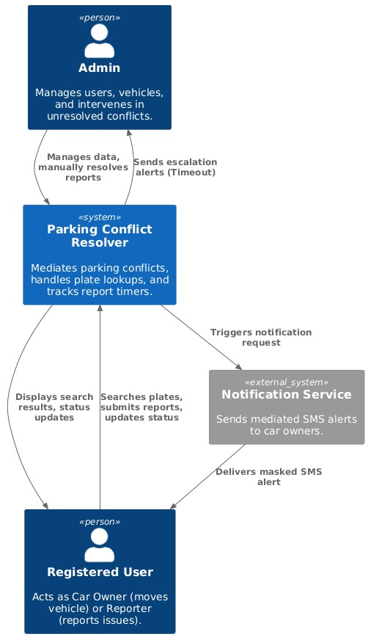

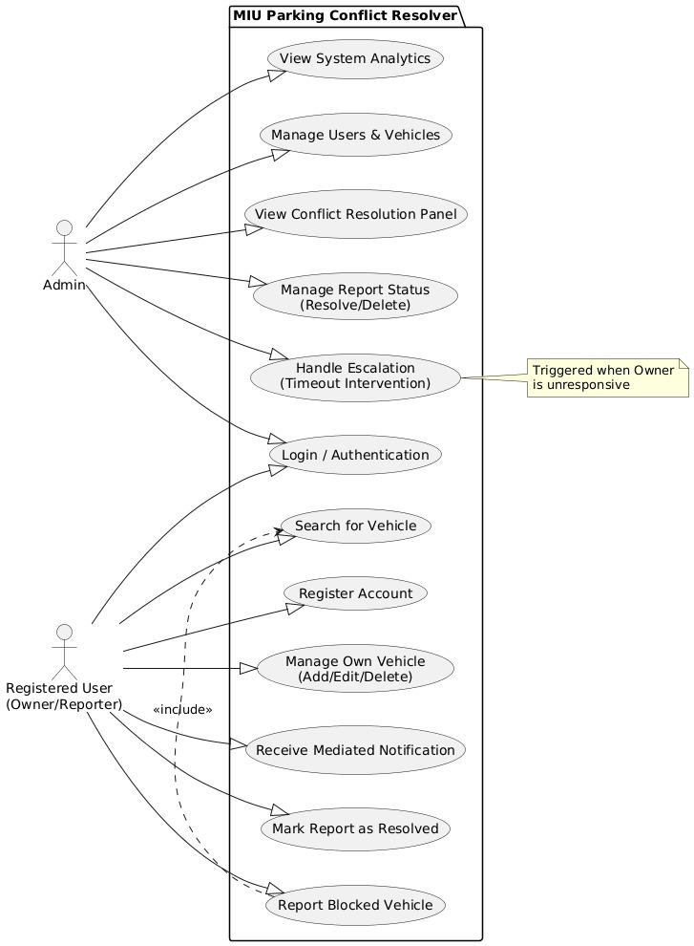
3.2 Use Case Diagram

3.3 Sequence Diagram
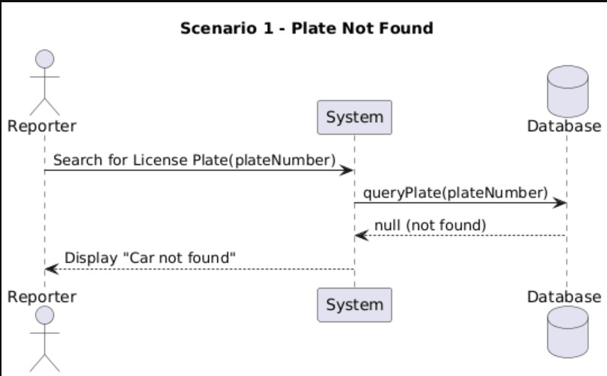
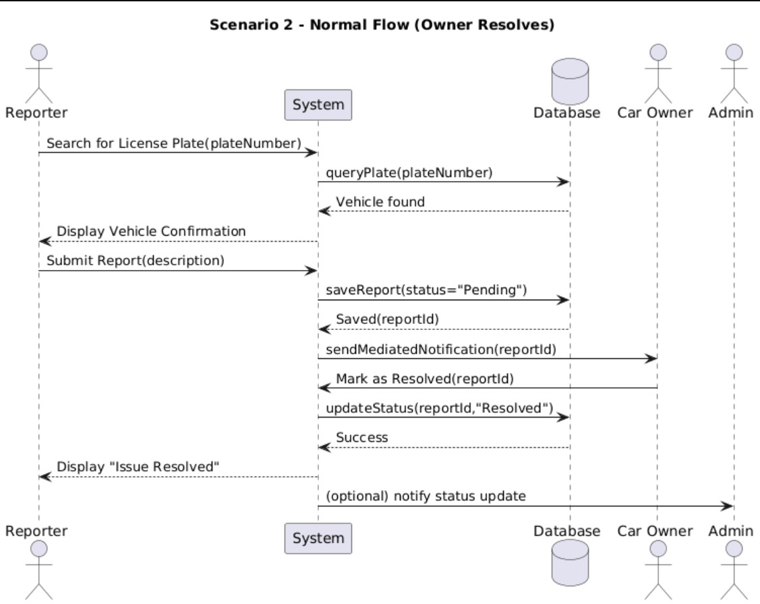

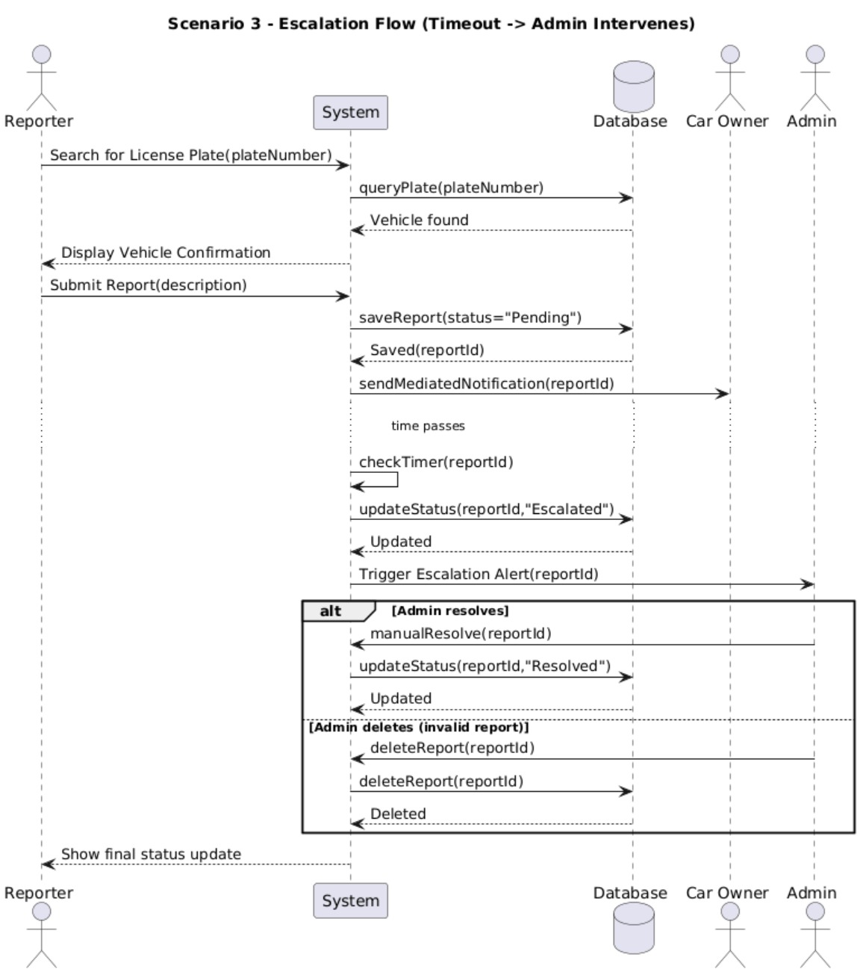

3.4 Class Diagram
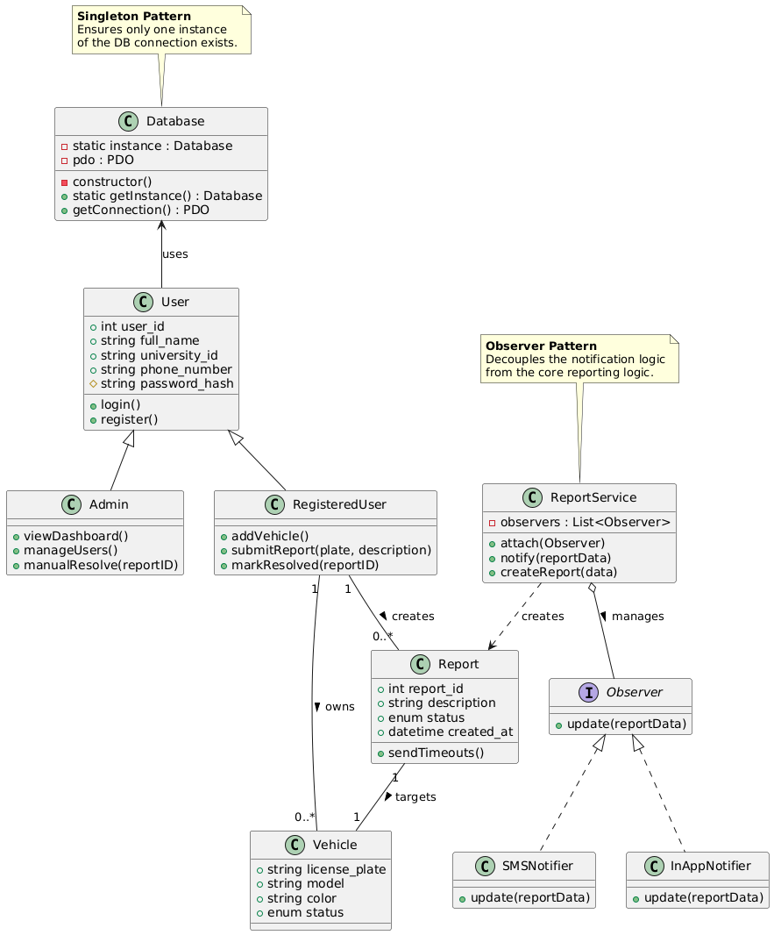

3.5 State Diagram
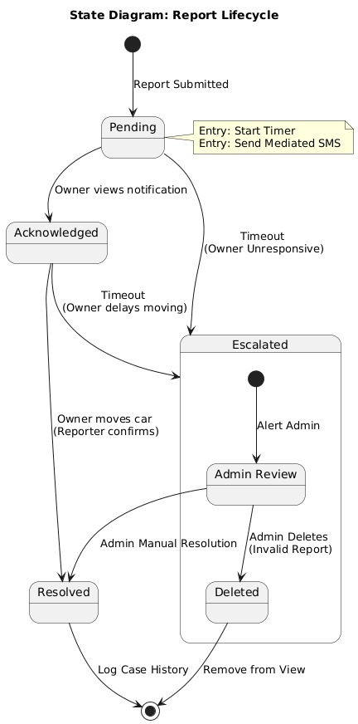

3.6 Database Schema and Singleton Design Pattern
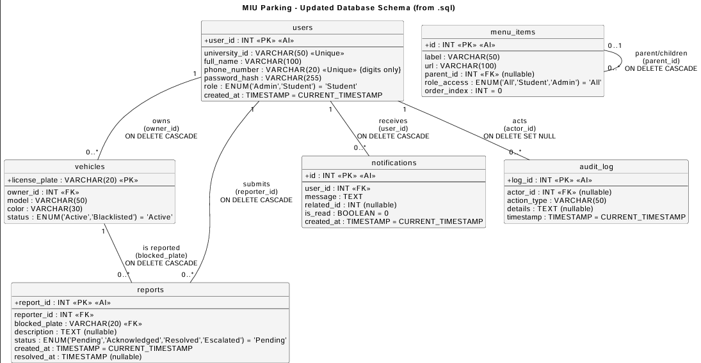
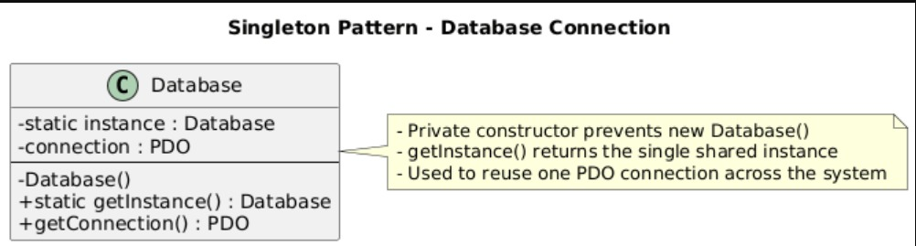

3.7 Observer Design Pattern
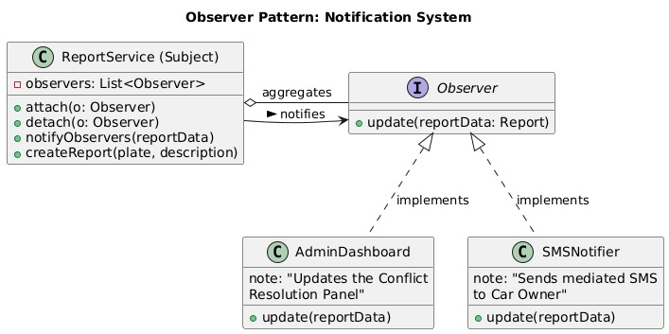

User Interface Design
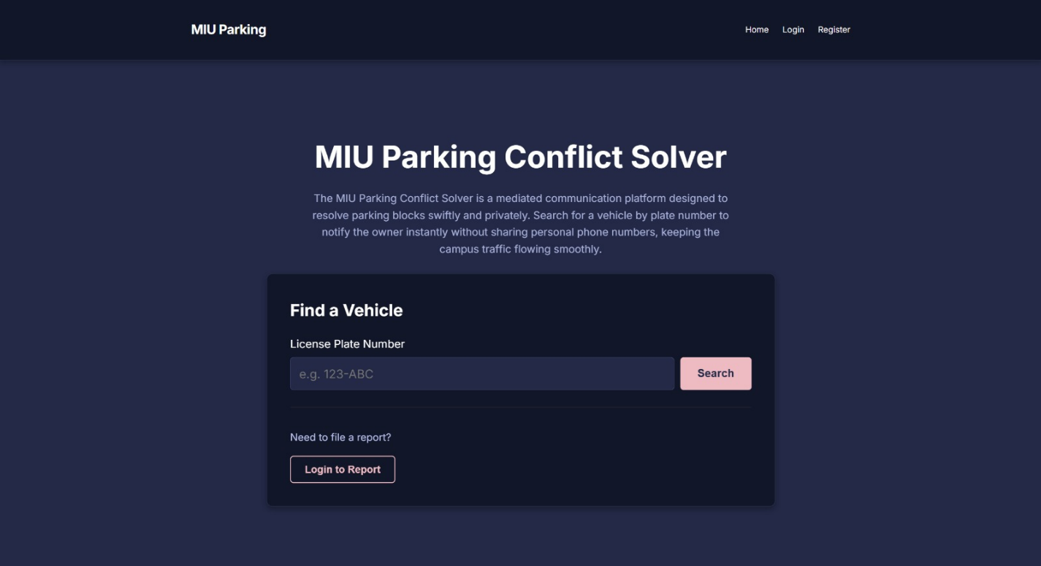
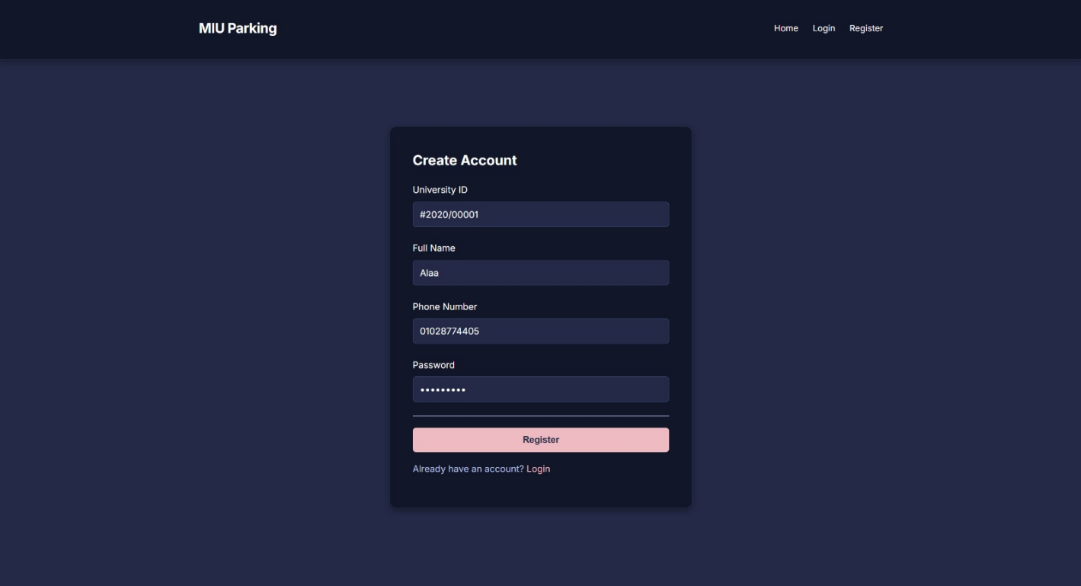

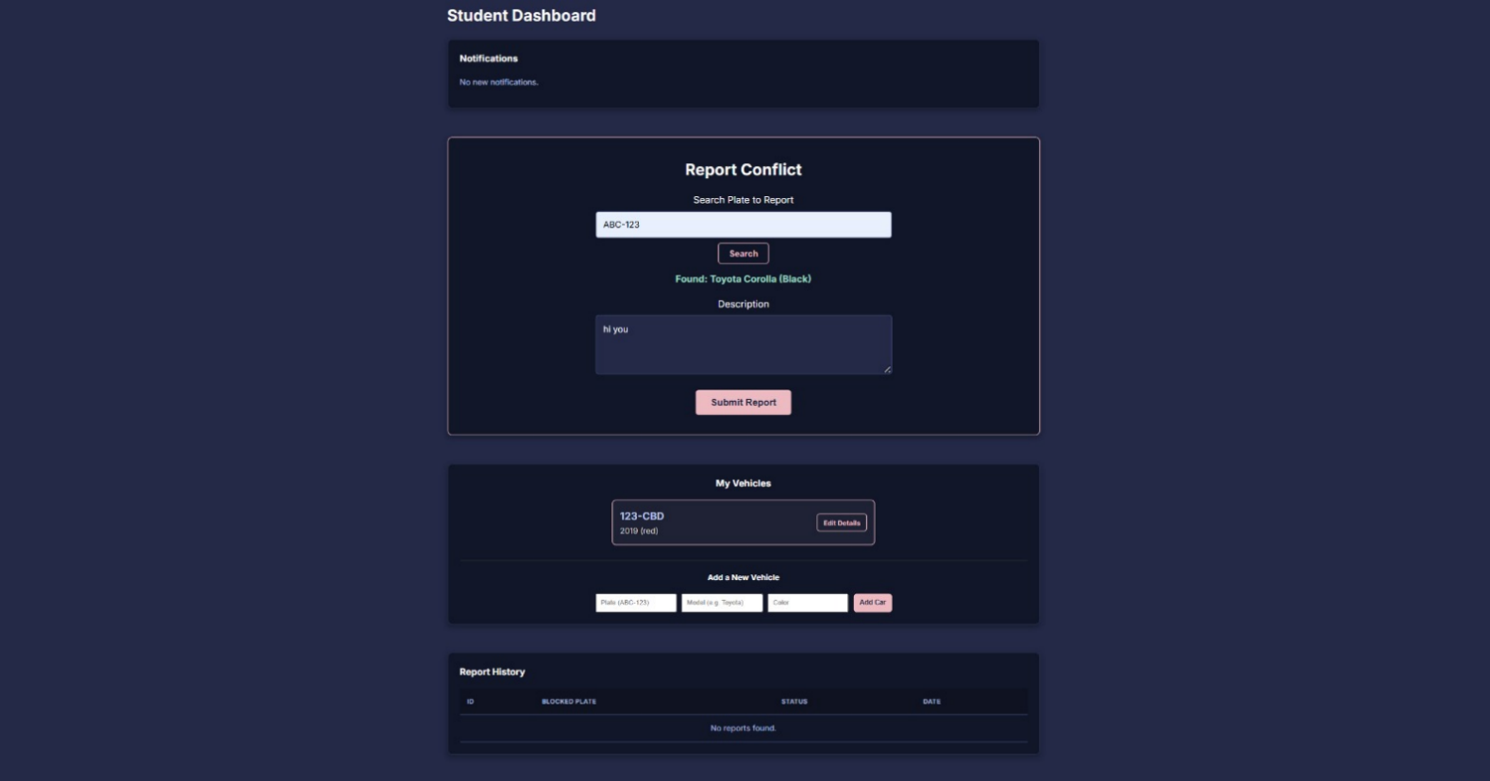



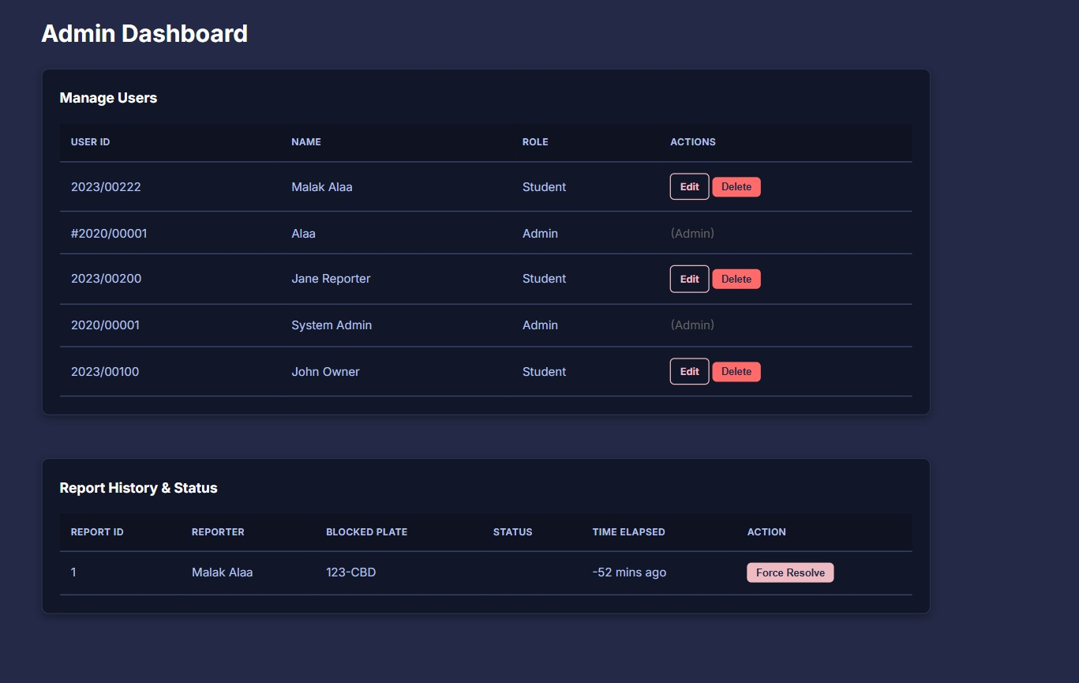

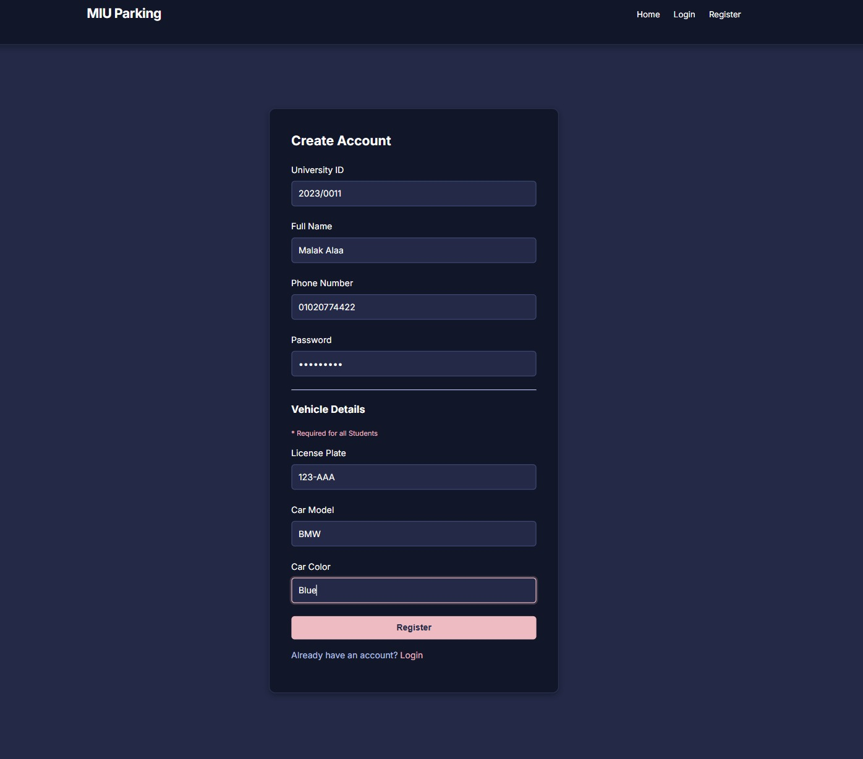
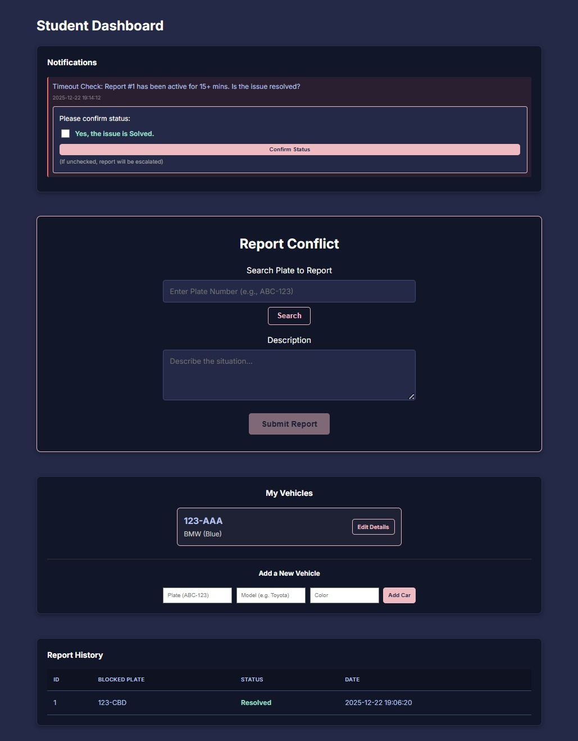

Project Plan
Phase | Description
Analysis | Requirements gathering and system modeling
Design | UML diagrams and database schema
Implementation | MVC development and pattern integration
Testing | Functional and UI testing
Deployment | Final submission and review

Task Distribution
All tasks were done equally by all team members.

